Day 5 : Test Plans & Release Testing
Learnt
- What is a Test Plan in TestRail
A Test Plan is a container for multiple test runs that together represent testing for one release or one sprint.
Release / Sprint → Test Plan → Multiple Test Runs
- Test Plan vs Test Run (clear difference)
Aspect | Test Plan | Test Run
Purpose | Release-level tracking | Execution-level tracking
Contains | Multiple test runs | Test cases
Used when | Multiple test types | Single execution cycle
Status | Overall release progress | Pass/Fail per test
Example | Sprint 1 Test Plan | Smoke Run

- Managing multiple runs per release
Project
└── Release (v1.2)
├── Test Plan
│ ├── Test Run – Smoke
│ ├── Test Run – Regression
│ └── Test Run – Integration
├── Test Run – Adhoc
└── Test Run – Hotfix Validation
In TestRail, a Release is a container, not an execution unit.
Within one Release, you can create:
- Multiple Test Plans
- Multiple Test Runs
- Multiple execution cycles
This allows parallel and iterative testing without duplicating test cases.

Practical
- Created Test Plan – Sprint 1 / Release 1
Step 1: Navigate
- Go to Test Runs & Results
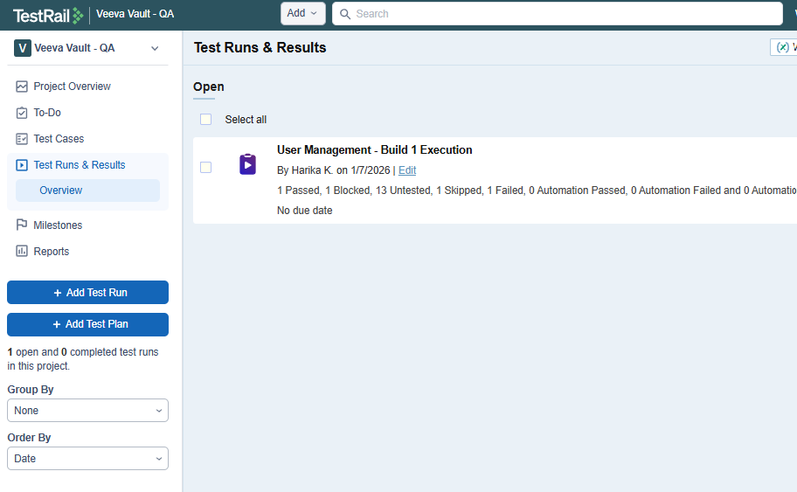
- Click Add Test Plan
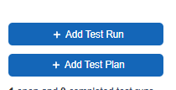
Step 2: Fill the Plan Details and click on Add Test Plan.
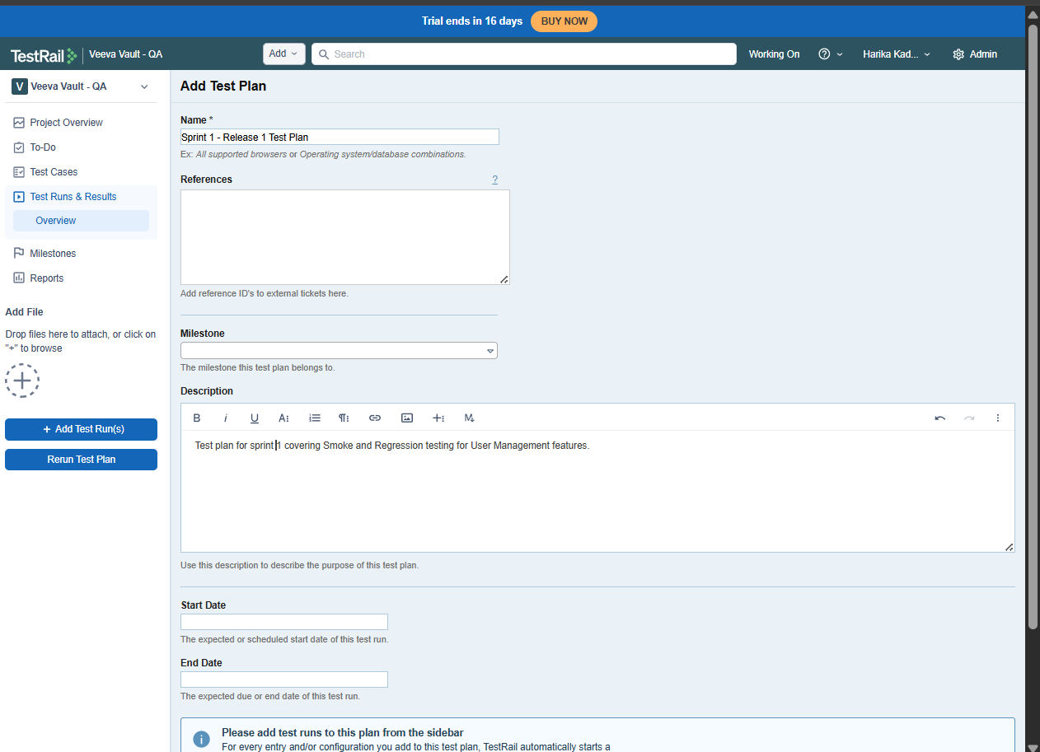
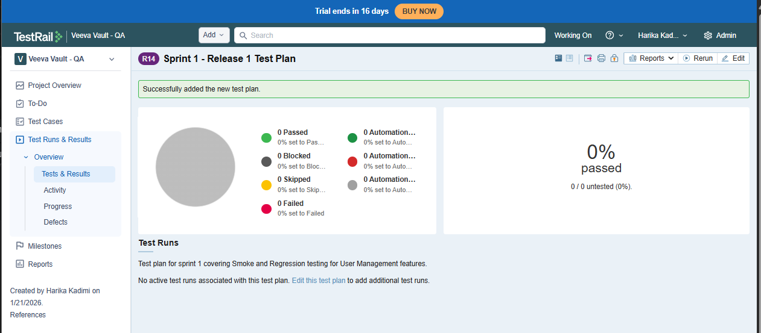
- Added multiple test runs:
  - Smoke - Smoke Testing is a shallow but critical validation performed on a new build to ensure that the core functionality is stable enough for further testing.
-> Is this build testable?
Run 1: Smoke Test Run
Step 1: Add Run
- Click Add Test Run
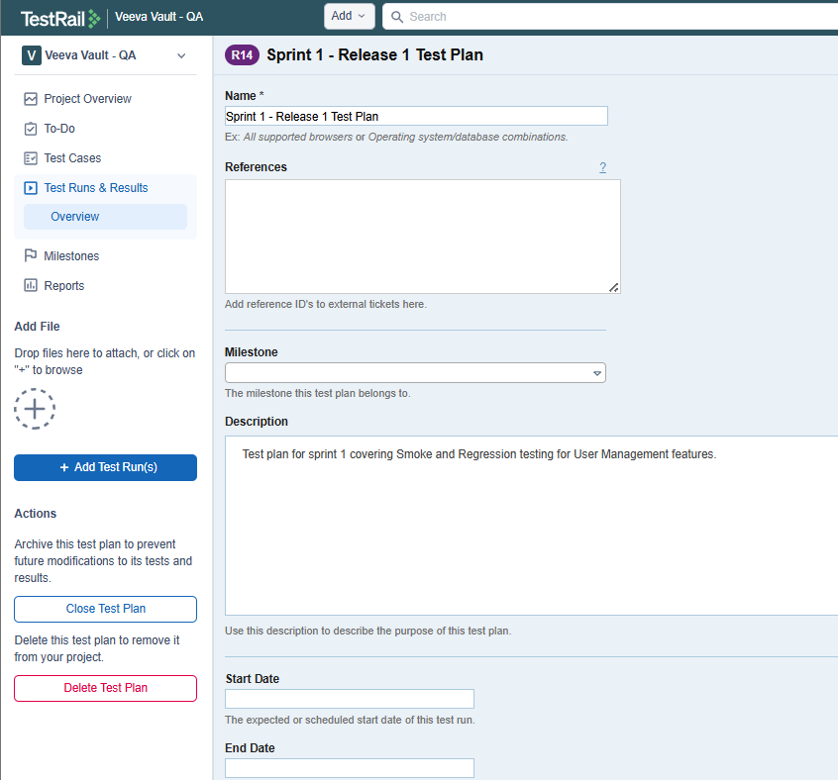
- Name:
Smoke Test – Sprint 1
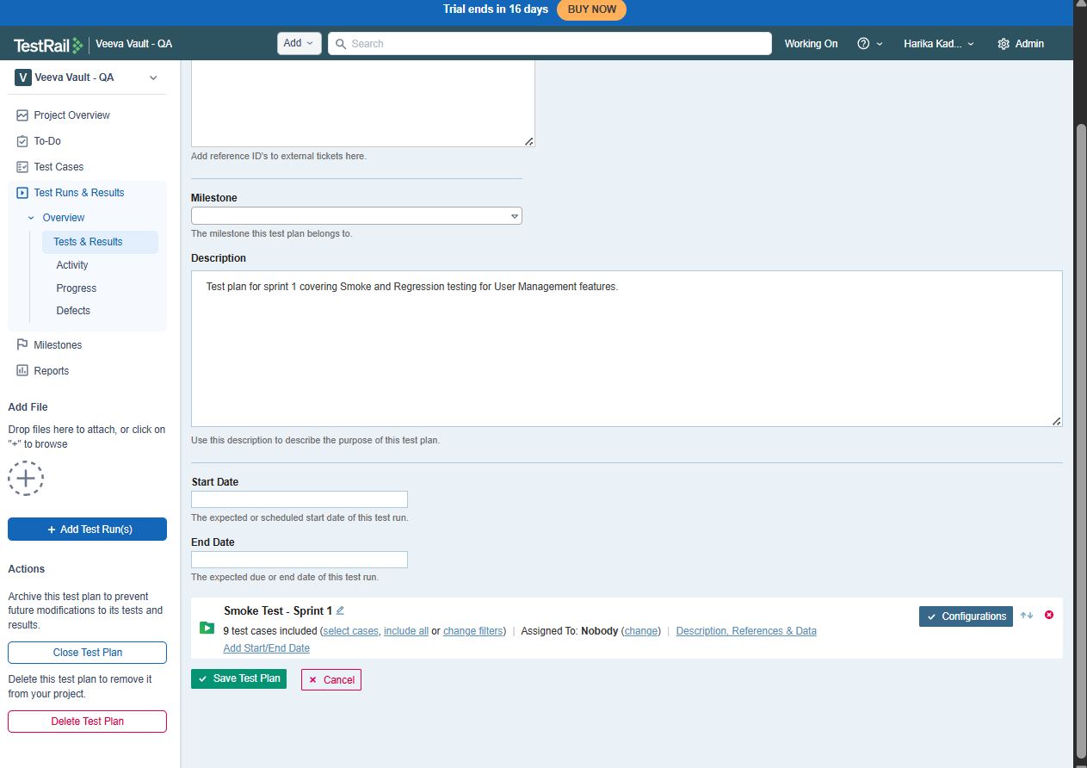
Step 2: Select Test Cases
- Choose:
  - Specific Smoke suite
OR
  - Filter using priority = High

Step 3: Assign
- Assigned To:
Yourself or team member
Click Add Test Run
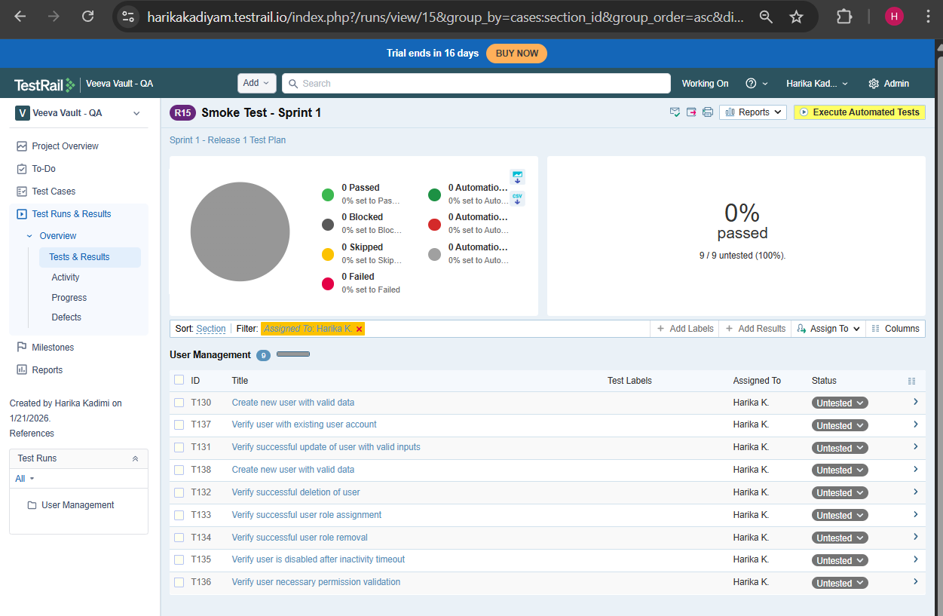

  - Regression - The primary purpose of regression testing is to ensure that recent code changes (like bug fixes, new features, or updates) haven't accidentally broken or negatively impacted existing, previously working functionality in a software application, acting as a safety net to maintain overall quality, stability, and reliability as the software evolves. It re-runs old tests to catch unintended side effects, ensuring that progress doesn't compromise core features like login, checkout, or other critical workflows.
  - Regression Test Run
  - Example: Regression Test Sprint 1
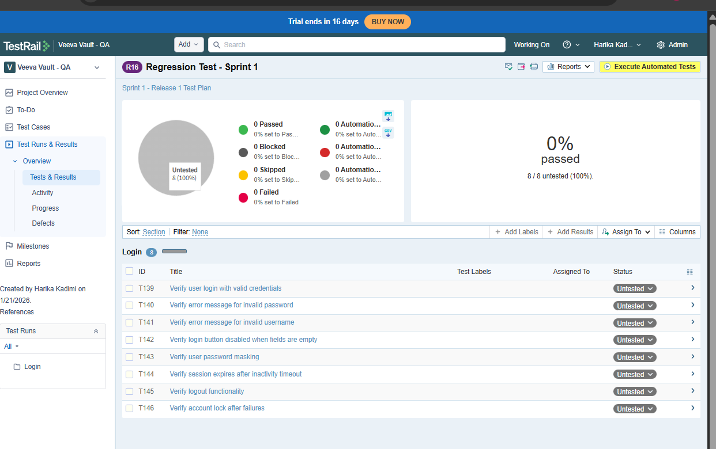
- Assigned test runs (Very Imp)
- Open a test run
- Select test cases
- Click assign to
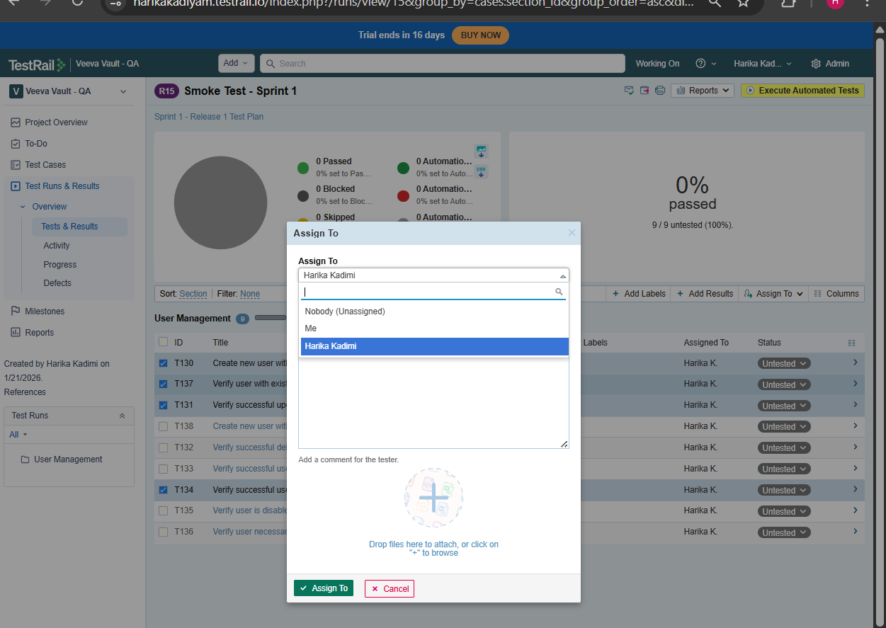
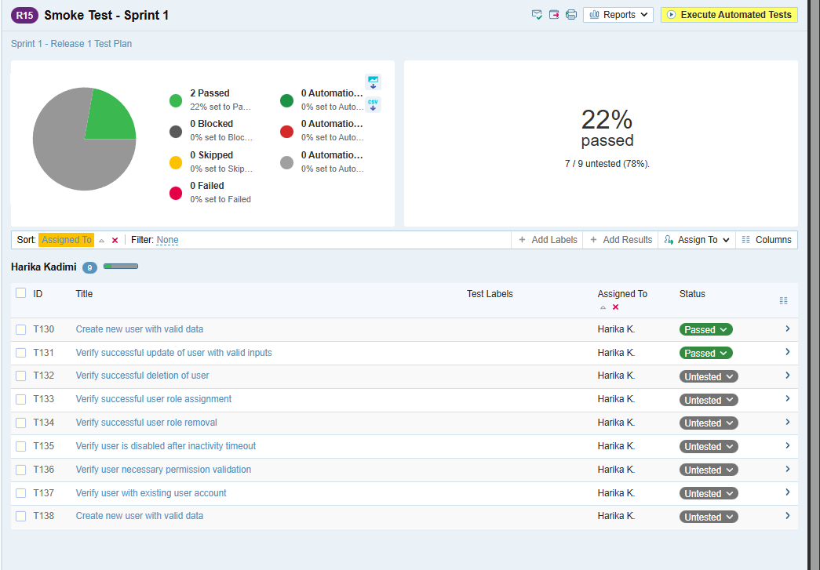
- Tracked execution progress
- Open any test run
- Mark test cases as:
- Pass
- Fail
- Blocked
